Amenity Order Process With The Concierge Assistant

Step 1. In the Concierge Assistant select the ‘logbook’ tab and click “add a log book entry”

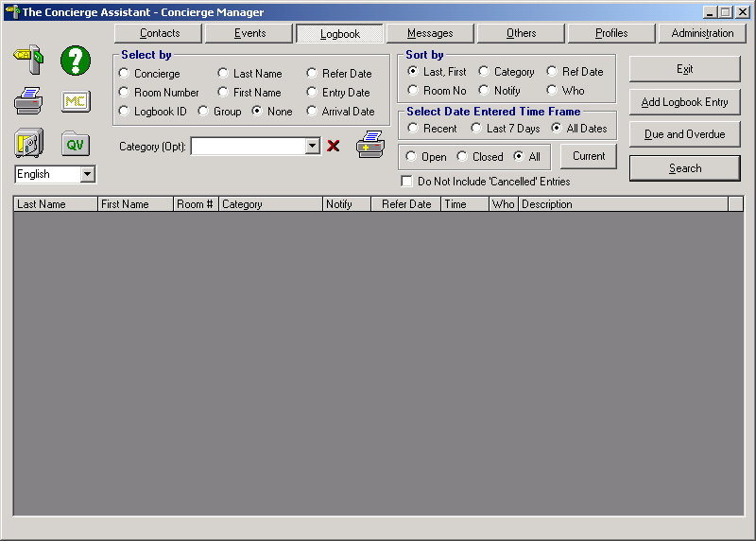

Fill out the Guest Information, select category “Amenity Order”, from that field tab 4 times to get to “data entry form”

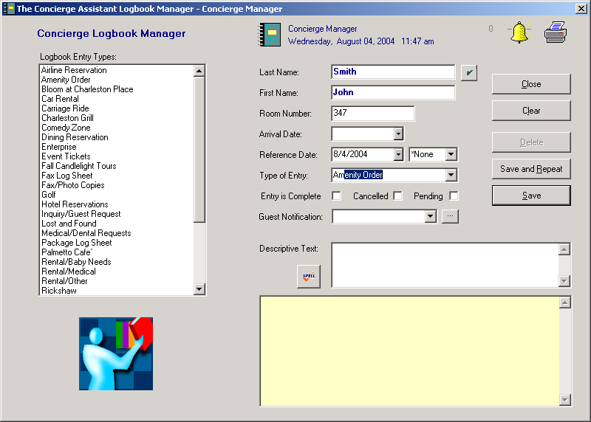
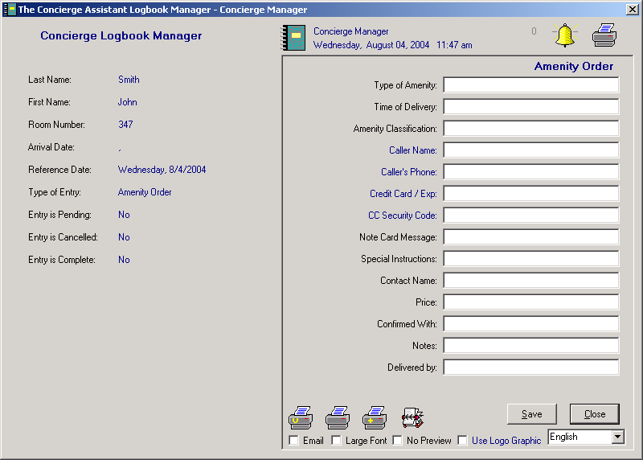

Step 2. Fill out information for amenity delivery and click save

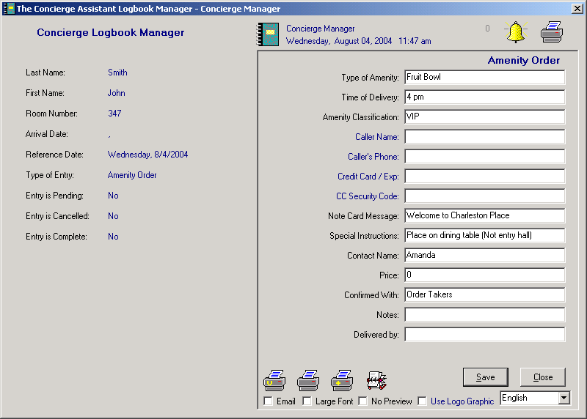

The room service manager or RS supervisor on duty will assign “delivered by and Price” and the status of order (Leave it on red, do not check pending or completed). Click save and close.

